Hari Raya Puasa Festival

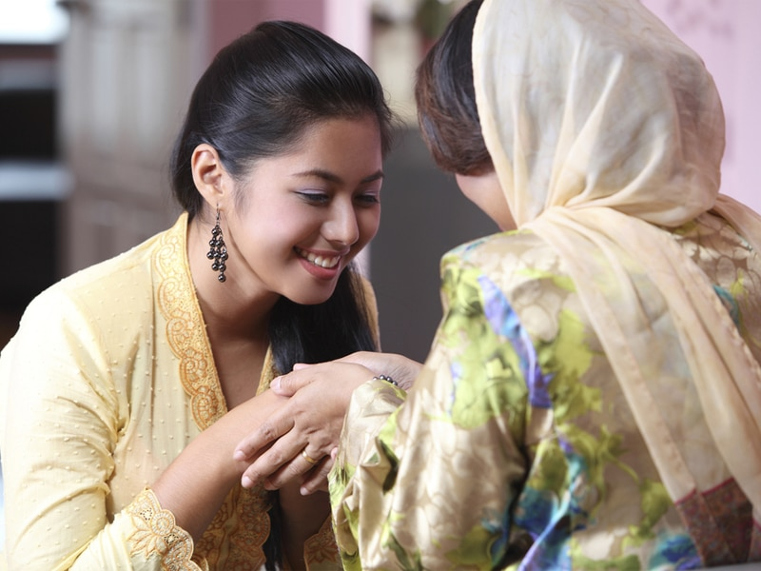

Hari Raya Puasa, also known as Hari Raya Aidilfitri or Eid al-Fitr, but more commonly known as just Hari Raya or Raya amongst Singaporeans, is celebrated by people of the Muslim faith.

It marks the end of the Islamic holy month of Ramadan – the month of dawn-to-sunset fasting – and is the time of forgiveness as families gather together to remember loved ones who have passed, and offer their apologies for any wrongdoings committed over the past year, with the younger ones in the family asking for forgiveness from their elders.

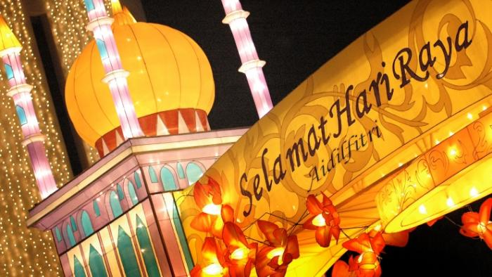

Among the other famous festivals in Singapore, this is the local version of Eid which is celebrated after the month-long fasting of Ramadaan. This is one of the traditional festivals in Singapore. The Muslims in Singapore put on new clothes and begin their day by visiting the nearest mosque where they offer their prayers. Rest of the day is spent by visiting the friends and relatives.

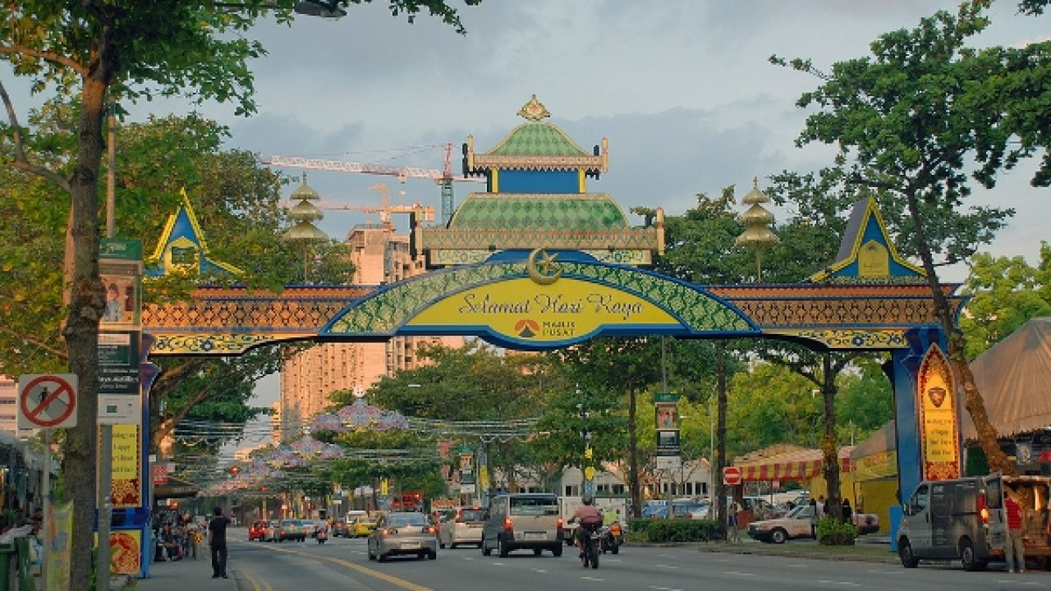

Hari Raya traditionally falls on the first day of Shawwal, the tenth month of the Islamic calendar. It varies each year because it’s dependent on the lunar calendar.

Muslims typically start their day by visiting the mosque to say special prayers. After which, they seek forgiveness from elders – for example, kids might ask for forgiveness from their parents. Before they head out to visit relatives and friends and start feasting on good food



Malay families don new clothes in a same or similar colour theme to represent family spirit, with the women dressed in baju kurung – a loose-fitting full-length dress consisting of a skirt and blouse – and the men in baju melayu – a loose-fitting shirt with long sleeves, worn with long pants with a sampin, a three-quarter length cloth made of woven materials with traditional patterns. Families also visit the graves of loved ones who have passed to pay their respects.

**Don’t miss:**Decorated bazaar at the Sultan Mosque, breaking fast rituals at any mosque in the neighborhood  
**When:**23rd – 24th May 2020